Instructions on Manuscript Preparation for Late-Breaking Abstracts
(Japanese Mass Spectrometry Co.¹, Institute of Mass Spectrometry², University of Mass Spectrometry³)
I.Suzuki^{1,2}, ○H.Tanaka², T.A.Edison ^{1,2,3}
Keywords: Instructions, Conference, Mass Spectrometry, Abstract, Preparation
This is the form for preparing a manuscript of your abstract submitted to the 62nd Annual Conference on Mass Spectrometry, 2014. Japanese authors are encouraged to prepare their abstracts in English. If you have downloaded the template file in the Microsoft Word document format from the MSSJ website (URL: http://www.mssj.jp), you can prepare abstracts by overwriting the template. Even if you do not overwrite the template, it is strongly recommended that your manuscript be matched with the style of this form. The page margins of your word processor must be set to 25 mm.
Please prepare your manuscript within one page length of A4 sheet. Exceeding one page, only the first page will be published in the book of abstracts. Since the abstract will be printed in black-and-white pages, do not use colored figures or characters.
It may happen that the book of abstracts will be issued before the conference dates. As regards other notes not shown in this instructions, please refer to the MSSJ website at first.
Times is recommended as the English character font. The first paragraph is a title in Japanese, whose character size is 12 pt. The second paragraph is author’s affiliations in Japanese, whose character size is 10 pt. The affiliations must be numbered with superscript notations and delimited with a bullet “・” between each affiliation, then enclosed in parentheses. The third paragraph is author’s names in Japanese, whose character size is 10 pt. Each name must has “furigana” printed beside and a superscript notation of the corresponding affiliation number, and delimited with a bullet “・”. The presenting author must be indicated by an open circle “○”.
The subsequent paragraphs are a title, affiliations, names in English, follows the styles of Japanese ones. Use comma “,” instead of bullet “・” as the delimiter. Change paragraph, then type “Keywords:” and indicate keywords, whose character size is 10 pt. Only the case of the manuscript prepared in English, the English “short abstract” can be omitted.
The character size of the main text is 10 pt. Identify references¹⁾ in the text by using superscript notations.
There are no restriction of styles of figures and tables, except they need serial numbers and titles.
Your manuscript must be submitted in the format of PDF. To ensure that the electronic version matches the print version, all fonts used must be embedded within a PDF file. To embed the fonts, select the Press Quality option in Adobe Acrobat. In Microsoft Word 2007 or later, select the ISO 19005-1 compliant (PDF/A) option after selecting PDF in the Save As menu. Please keep the file size less than 3 megabyte. After submitting your manuscript on-line, you may receive an e-mail notification, which contains instructions to check the appearance of the printed abstract. Please make sure that the appearance matches with your manuscript.

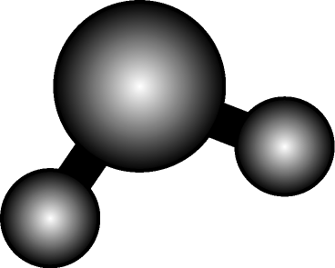

Fig.1. Schematic diagram of H₂O molecule

References
- The character size is 10 pt. The following format is recommended.
- J.S.Brodbelt et al., Mass Spectrom. Rev., 16, 91-110 (1989).

